AI-CliniScan: Multimodal Deep Learning for Thoracic Abnormality Detection
Project Author: Tirumani Surya Siva Shankar

Table of Contents
- Project Description
- Dataset Used
- Environment Setup
- Data Exploration
- Data Preprocessing 5.1. Image Loading 5.2. Ground Truth Extraction 5.3. Image Resizing & Downscaling 5.4. Advanced Data Augmentation 5.5. Tensor Conversion
- Proposed System
- Training Pipeline
- Conclusion

1. Project Description
AI-CliniScan is a multimodal, deep-learning-based computer vision system designed to assist medical professionals in detecting and localizing thoracic abnormalities in chest X-rays. The primary goal of this project is to act as an automated triage engine for Emergency Room (ER) physicians and under-resourced clinics. By pre-screening imaging queues, the system highlights critical "needles in the haystack" (such as faint nodules or massive aortic enlargements) within milliseconds. This project implements a full end-to-end workflow, from custom dataset augmentation using Albumentations to the deployment of a dual-model architecture featuring YOLOv8m for object detection and ResNet18 for image classification, culminating in a highly interpretable Streamlit web application.

2. Dataset Used
The project utilizes a highly specialized medical dataset comprising 5,000 annotated chest X-rays. For each image in the dataset:
- A high-resolution .jpg or .png image file is provided.
- A corresponding .txt ground truth file contains the YOLO-formatted bounding box coordinates.
The dataset features 14 distinct diagnostic classes representing various thoracic pathologies: 0 - Aortic enlargement, 1 - Atelectasis, 2 - Calcification, 3 - Cardiomegaly, 4 - Consolidation, 5 - ILD, 6 - Infiltration, 7 - Lung Opacity, 8 - Nodule/Mass, 9 - Other lesion, 10 - Pleural effusion, 11 - Pleural thickening, 12 - Pneumothorax, 13 - Pulmonary fibrosis.

3. Environment Setup
The project was developed in Python utilizing Visual Studio Code. The environment was specifically configured to leverage Apple Silicon (MPS) for hardware acceleration. Key libraries include:
- PyTorch & Ultralytics: For building, fine-tuning, and evaluating the ResNet18 classification and YOLOv8m detection models.
- Albumentations: For strictly medical, advanced image augmentation pipelines.
- Grad-CAM: For generating gradient-weighted class activation heatmaps to ensure model interpretability.
- OpenCV & Pillow: For image parsing, resizing, and visual rendering.
- Streamlit: For developing the interactive clinical frontend interface.

4. Data Exploration
Before preprocessing, the dataset directory structure was thoroughly validated. The exploration involved:
- Verifying the structural integrity of the images/train and labels/train subdirectories.
- Visualizing the spatial distribution of bounding boxes to understand the physical location of class-specific anomalies (e.g., verifying that Pleural Effusions pooled correctly at the lung bases).
- Confirming the absence of critical data leakage between the training and validation splits.

5. Data Preprocessing
This stage prepares raw X-ray scans and their corresponding text annotations for neural network ingestion.

5.1. Image Loading
Images are loaded utilizing OpenCV and converted from BGR to RGB color spaces to ensure consistency across both the YOLO and ResNet architectures. Purpose: Standardizes the input format and prepares the matrix for accurate pixel normalization.

5.2. Ground Truth Extraction
A custom PyTorch Dataset class was engineered to dynamically parse the YOLO text annotations.
Steps:
- The pipeline scans the labels directory for text files matching the image filenames.
- For the classification model, the presence of a non-empty text file automatically assigns a binary label of 1 (Sick), while its absence assigns 0 (Healthy).
- Purpose: Allows a dataset structured strictly for object detection to be seamlessly utilized for image classification.

5.3. Image Resizing & Downscaling
Medical X-rays possess highly variable, extremely large original resolutions. Steps: All dataset images were uniformly downscaled to a strict 512x512 resolution. Purpose: Prevents local memory overflow during training, standardizes the convolutional input matrices, and drastically accelerates inference times without sacrificing critical anatomical features.

5.4. Advanced Data Augmentation
To improve model robustness and prevent overfitting, the Albumentations library was integrated to apply medically safe transformations.
Steps:
- CLAHE (Contrast Limited Adaptive Histogram Equalization) was applied to enhance the contrast between lung tissue and rib bones.
- Controlled spatial transformations (Horizontal Flipping and max 15-degree Rotations) were applied. Purpose: Simulates the natural variance found in real-world clinical settings, such as misaligned patient posture or varying radiation exposures, teaching the AI to focus on the pathology rather than lighting artifacts.
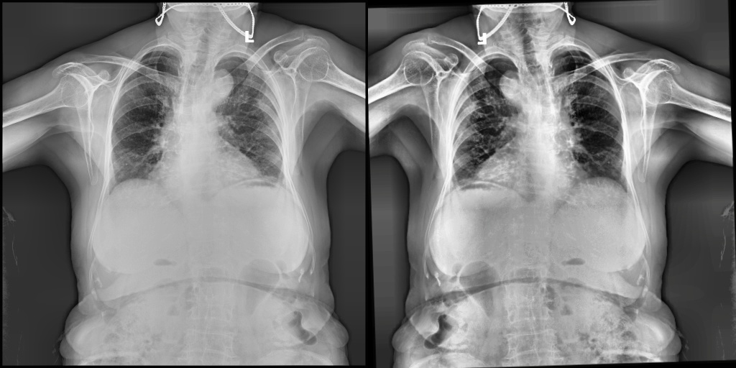

5.5. Tensor Conversion
Deep learning models require multi-dimensional tensor inputs. Steps: Image arrays were converted into PyTorch tensors, and pixel values were normalized to standard ImageNet statistics (Mean: [0.485, 0.456, 0.406], Std: [0.229, 0.224, 0.225]). Purpose: Stabilizes the gradient descent process and accelerates the convergence of the AdamW optimizer.

6. Proposed System
- Raw Image Input: The user uploads a standard chest X-ray via the Streamlit web interface.
- Preprocessing: The system resizes and normalizes the image array in the background.
- Dual-Model Inference:
  - YOLOv8m: Scans the spatial features to localize specific pathologies and draws bounding boxes around structural abnormalities.
  - ResNet18: Analyzes global pixel density to classify the overall health state of the patient.
- Interpretability Engine: The system utilizes Grad-CAM to extract data from ResNet's deepest convolutional layer (layer4), generating a color-coded heatmap that highlights the specific pixels driving the model's clinical decision.
- Clinical Output: The final annotated X-ray and heatmap are displayed on the frontend, acting as an instant "second opinion" for the attending physician.

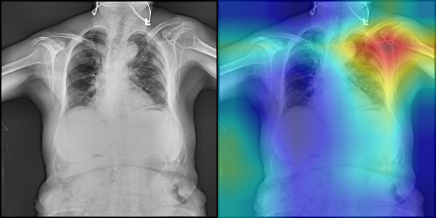

7. Training Pipeline
The training pipeline was optimized using advanced hyperparameter tuning for both architectures:
- Detection Model (YOLOv8m):
  - Transitioned from a baseline YOLOv8n to a medium architecture for higher feature extraction capability.
  - Replaced standard optimizers with AdamW for superior weight decay management.
  - Retained Non-Maximum Suppression (NMS) to eliminate overlapping bounding boxes on static images.
- Classification Model (ResNet18):
  - Implemented Transfer Learning utilizing pre-trained ImageNet weights.
  - Configured a custom fully connected layer (model.fc) to output two distinct classes.
  - Tuned with a learning rate of 0.001 and weight decay of 1e-4.
- Evaluation Metrics: The models were comprehensively evaluated on a dedicated validation set utilizing Precision-Recall (PR) curves, F1-Confidence curves, and Confusion Matrices to accurately gauge localization and classification thresholds.

8. Conclusion
The comprehensive development of the AI-CliniScan system across Milestones 1, 2, and 3 has been successfully completed. Raw medical data was successfully structured, augmented using advanced Albumentations techniques, and normalized for neural network ingestion. The project successfully executed hyperparameter tuning on both a YOLOv8m detection model and a ResNet18 classification model. Furthermore, advanced interpretability requirements were satisfied through the generation of high-resolution bounding box visualizations and Grad-CAM heatmaps. By deploying these trained assets into a responsive Streamlit application, this project successfully demonstrates a highly robust, medically sound AI triage tool ready for clinical evaluation.

